Name : Alveena naz
Reg no. FA25-BSE-010
OOP Assignment 1

Class Design:
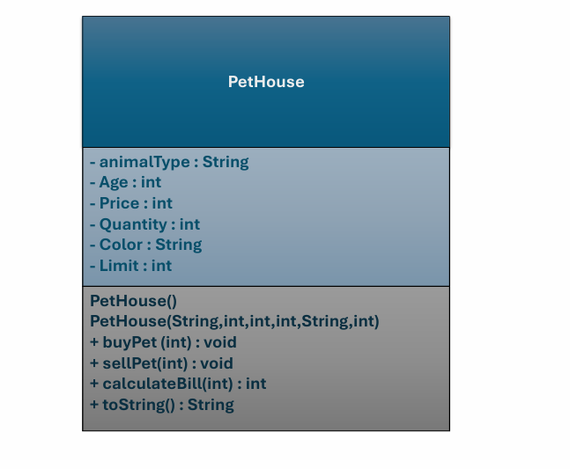

Source code:

//main class
import java.util.Scanner;
public class Ruunner {
public static void main(String[] args) {
Scanner input = new Scanner(System.in);
PetHouse cat1 = new PetHouse("cat",10,1500,4,"Persian",20);

System.out.println("1.buy pet\n2.Sell pet\n3.calculateBill\n4.Display pet details\n5.Exit");
int choice = input.nextInt();
switch(choice)
{
case 1:
{
System.out.println("Enter quantity of pet");
int qty = input.nextInt();
cat1.buyPet(qty);
break;
}
case 2:
{
System.out.println("Enter quantity of pet");
int qty = input.nextInt();
cat1.sellPet(qty);
break;
}
case 3:
{
System.out.println("Enter quantity of pet to purchase");
int qty = input.nextInt();
System.out.println("your total bill is " + cat1.calculateBill(qty));
break;
}
case 4:
{
System.out.println(cat1.toString());
break;
}
case 5:
{
System.out.println("Exit successfully");
break;
}
default:
System.out.println("Invalid choice");

}

}

}

// PetHouse class
public class PetHouse
{
private String animalType;
private int age;
private int price;
private int quantity;
private String breed;
private int maximumCapacity;
//default constructor
PetHouse(){}
// papametrized constructor
PetHouse(String animalType, int age,int price,int quantity, String breed, int limit)
{
this.animalType= animalType;
this.age = age;
this.price = price;
this.quantity= quantity;
this.breed = breed;
this.maximumCapacity = limit;

}
public void setAnimalType(String type)
{
this.animalType=type;
}
public void setAge(int age)
{
this.age=age;
}
public void setPrice(int price)
{
this.price=price;
}
public void setQuantity(int qty)
{
this.quantity= qty;
}
public void setBreed(String breed)
{
this.breed=breed;
}
public void setLimit(int limit)
{
this.maximumCapacity=limit;
}
//getters
public String getAnimalType()
{
return animalType;
}
public int getAge()
{
return age;
}
public int getPrice(){
return price;
}
public int getQuantity(){
return quantity;
}
public String getBreed(){
return breed;
}
public int getLimit(){
return maximumCapacity;
}
//methods
public void buyPet(int qty)
{
if(quantity + qty > maximumCapacity)
{
System.out.println("Shop capacity exceeded.");
return;
}
quantity+=qty;
System.out.println("Pet stock added successfully");
}
public void sellPet(int qty)
{
if(qty > quantity){
System.out.println("Out of stock");
return;
}
quantity-=qty;
System.out.println("pet sold successfully.");
}
public int calculateBill(int qty)
{
return price * qty;
}
@Override
public String toString()
{
return animalType + " age: " + age + " price " + price + " Quantity " + quantity + " Breed: " + breed;
}
}

OUTPUT:

